**Experiment No. : 5**

**Title: Single Server system (The Grocery Store problem)**

**Batch: B–1 Roll No.: 16010422234 Experiment No.: 5**

**______________________________________________________________________________**

**Aim:** To simulate Single Channel Queuing System

**______________________________________________________________________________**

**Resources needed:** Microsoft Excel / Open Office

**______________________________________________________________________________**

**Problem Statement:**

A small grocery store has only one checkout counter. Customers arrive at this check out counter at random.

In order to evaluate the system performance

a) Let the arrival distribution be uniformly distributed between 1 to 10 minutes.

b) Let service time distribution be as:

| Service  Time(minutes) | 1 | 2 | 3 | 4 | 5 | 6 |
| --- | --- | --- | --- | --- | --- | --- |
| Probability | 0.05 | 0.1 | 0.2 | 0.3 | 0.25 | 0.1 |

c) Perform simulation for 20 customers and compute the performance measures.

**Concepts:**

The key elements of the queuing system are customers & servers. The term customer can refer to people, machines, and trucks. The server might refer to the receptionist, person etc.

A queuing system is described by its calling population, the nature of the arrivals, the service mechanism, the system capacity and the queuing discipline.

**1. Calling population**:

The population of potential customers is referred to as the calling population. In systems with a large population the calling population is usually assumed to be infinity. E.g. population of potential customers of a bank. The actual population may be finite. The main difference between finite & infinite population is based on the definition of the arrival rate.

**2. System Capacity**:

The system capacity has no limit meaning that any no. of units comes and waits in the queue. In many queuing systems there is a limit to the no. of customers that may be waiting.

**3. Nature of Arrivals**:

Arrivals for service occur at a time in random fashion and once they join the waiting line, they are served.

**4. Service Mechanism:**

The units are served in order of their arrival by a single server or a channel.

**5. Queuing Discipline:**

It refers to the logical ordering of customers that will be chosen for service when a server becomes busy.

**6. State Of System:**

It is the no. of units in the system & status of server (busy / idle).

**7. Events:**

It is a set of circumstances that causes an instantaneous change in the state of system

Possible events in a single server system:

* The Entry of a unit in the system.
* Departure of unit from system on completion of service.

**8. Simulation Clock:**

It is used to track simulation time.

**Conceptual Model:**

The grocery store with one checkout counter is simulated by using a Semi – automatic approach by using a simulation table to record successive system snapshots as time advances.

The simulation requires mainly a service time distribution and an interarrival time distribution of customers.

**Characteristics of Grocery Store checkout counter System:**

I) Calling Population: Infinite.

II) System capacity: Infinite.

III) Nature of Arrival: Random arrival uniformly distributed.

IV) Service Mechanism: At a time only one customer is served; service time is random, probability distribution is given.

V) Queuing Discipline: FIFO.

**System State:**

I) Waiting time in the queue.

II) Status of Able and Baker (Busy / Idle)

III) Time the customer spends in the system.

**Entities**:

The entities in the single channel queue are queue & server.

**Events:**

a) Arrival Event

b) Departure Event

**Activities:**

a) Interarrival time.

b) Service time.

**Delay:**

Waiting time in the queue.

**Use of Random Nos.:**

* For generating interarrival time
* For generating service time
* RAND() or RANDBETWEEN() function of Excel can be used to generate random nos. in simulation.

**Real life Examples:**

1. Customers queuing in the Telephone Bill Payment System

Customers form a single channel queue. Customers are chosen in FIFO manner.

**Performance measures:**

1. Average Waiting Time = (Total time customers wait in queue) / (Total no. of

Customers)

2. Probability. Of Customers waiting =(No. of Customers who waits) / (Total no. of

Customers)

3. Probability. Of Idle Server = (Total Idle Time Of Server) / (Total runtime of simulation)

4. Average Time between Arrival = (Total Time between arrivals) / (No. of arrivals)-1

5. Average Waiting Time of Those Who Wait = (Total Time Customer waits in queue) / (Total no. of Customers who wait)

6. Average Time Customers Spends In System = (Total Time Customer spends in system) / (Total no. of Customers).

**Activity Diagram:**

**1) Flowchart Arrival event:**



Arrival Event

**NO YES**

Server

Busy?

Enters service

Unit Enters queue

**2) Flowchart Departure event:**

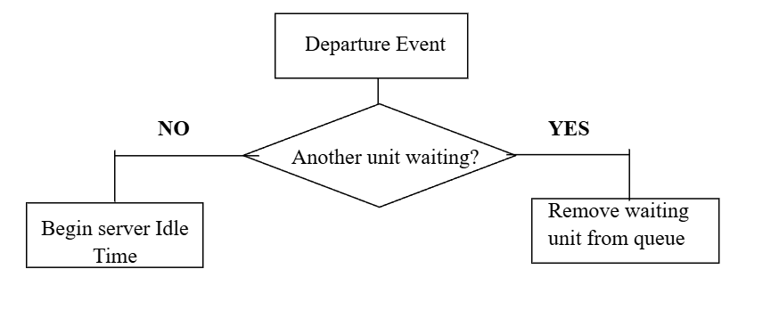

**__________________________________________________________________________**

**Results: (Program printout as per the format)**

**Program:**

*(Problem solved using simulation table and the given inputs with MS-Excel.)*

**__________________________________________________________________________**

**Output**:

*(In printed form i.e. Simulation table along with the performance measures and histogram showing number of customers against waiting time)*

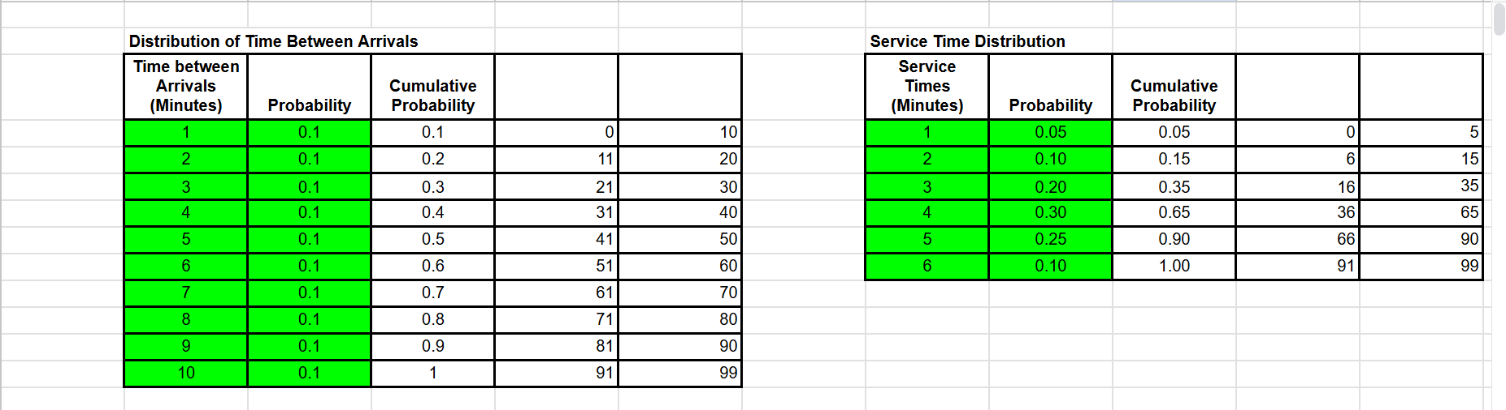

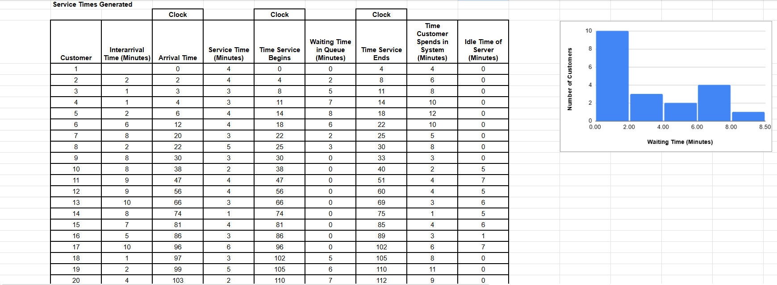

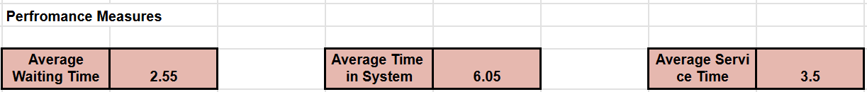

***Link to the google sheet:*** [***EXP-5***](https://docs.google.com/spreadsheets/d/17keXoHqulYAjlYjzQ_2bvxkNmrFgeX-5eTYh29jWZ04/edit?usp=sharing)

**__________________________________________________________________________**

**Questions:**

**1) What is simulation? List the different types of simulation.**

**Ans:** Simulation is the process of modeling a real-world system or process using a mathematical or computer-based model to observe its behavior under different conditions. In this case, the simulation models the operation of a grocery store checkout counter to analyze the queuing process and system performance.

Types of Simulation:

* Monte Carlo Simulation: This method uses random sampling to obtain numerical results, typically used when the system has probabilistic behavior.
* Discrete Event Simulation (DES): This simulates the operation of a system as a discrete sequence of events in time, where each event changes the state of the system.
* Continuous Simulation: In continuous simulation, the model is described by continuous equations, and the system evolves continuously over time (used for systems that do not exhibit discrete events).
* Agent-based Simulation: This simulation models the interactions between agents (individual entities) to evaluate system performance.
* System Dynamics Simulation: Used to model complex systems and feedback loops by studying how variables interact and change over time.

**2) List the queue disciplines used in simulation.**

* FIFO (First In, First Out): The first customer to arrive is the first to be served.
* LIFO (Last In, First Out): The last customer to arrive is the first to be served.
* Priority Queueing: Customers are served based on priority (not just arrival time), where some customers may be served before others.
* Round Robin Queueing: Customers are served in a cyclic order, typically used in computing systems.
* Shortest Job First (SJF): The customer with the shortest service time is served first.

**__________________________________________________________________________**

**Outcomes: CO1–Apply the experimental process of a simulation using spreadsheets as well as Simulation language/package.**

**__________________________________________________________________________**

**Conclusion:**

The simulation of a single channel queuing system for the grocery store checkout counter provided valuable insights into the system's performance. By modeling random customer arrivals and service times, we were able to calculate key performance measures such as average waiting time and server idle probability. This experiment demonstrates how simulations can help optimize real-world systems and improve efficiency by analyzing customer flow and service dynamics.

**__________________________________________________________________________**

**Grade: AA / AB / BB / BC / CC / CD / DD**

**Signature of faculty in-charge with date**

**__________________________________________________________________________**

**References:**

**Books/ Journals/ Websites:**

1. Jerry Banks, John Carson, Barry Nelson, and David M. Nicol; “Discrete Event System

Simulation”, Fifth Edition, Pearson Education.

2. Jerry Banks, John Carson, Barry Nelson, and David M. Nicol; “Discrete Event System

Simulation”, Third Edition, Pearson Education.

3. Real Queuing Examples:[http://www2.uwindsor.ca/hl](http://www2.uwindsor.ca/)ynka/qreal.html This site contains excerpts from news articlesthat deal with aspects of waiting lines.

4. ClearQ :[http://clearq.com/ This c](http://clearq.com/)ompany produces “take-a-number” systems for

servicefacilities (e.g., delis), but also providesperformance information about the waiting line.

5. Qmatic:[http://us.q-matic.com/index.htmlThi](http://us.q-matic.com/index.html)scompany produces informational displays andother products to keep customers informedabout waiting times.

6. “Queuing Presentation” by Richard Larson, givenat the Institute for Operations Research

and the Management.

7. cience[s:http://caes.mit.edu/people/larson/MontrealINFORMS1/sld001.htm.](http://caes.mit.edu/people/larson/MontrealINFORMS1/sld001.htm)

8. Queuing Tutor :[http://www.dcs.ed.ac.uk/home/jeh/Simjava/queueing](http://www.dcs.ed.ac.uk/home/jeh/Simjava/queuei)/mm1_q/mm1_q.html This site has twoanimated displays of waiting lines. The user canchange arrival and service rates to see howperformance is affected.

9. Myron Hlynka‟s Queuing Page:http:www2.uwindsor.ca/hlynka/queue.html This web site contains information about waiting linesas well as links to other interesting sites.

10. Queuing ToolPa[k:http://www.bus.ualberta.ca/aingolfsson/qtp/](http://www.bus.ualberta.ca/aingolfsson/qtp/)

11. The Queuing ToolPak is an Excel add-in that allowsyou to easily compute performance measures fora number of different waiting line models